Mason Taylor T-Shirt and Bracelet Order Form
Proceeds will go towards the Mason Taylor Scholarship Fund

Name:
Email/Contact Phone Number:
T-Shirts $10.00 Each
Please Indicate Quantity and Size
Kids Adults
Small ______ Small ______ XX-Large ______
Medium ______ Medium _____ _ XXX-Large _____ _
Large ______ Large ______
X-Large ______ X-Large ______
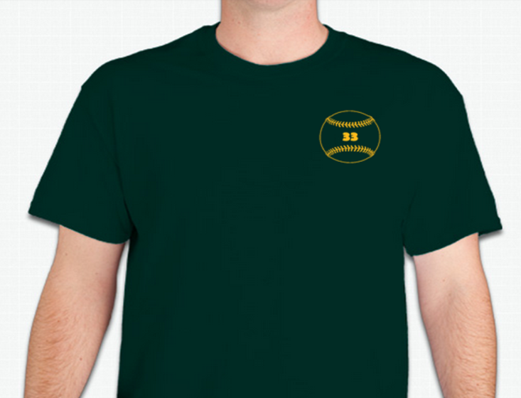
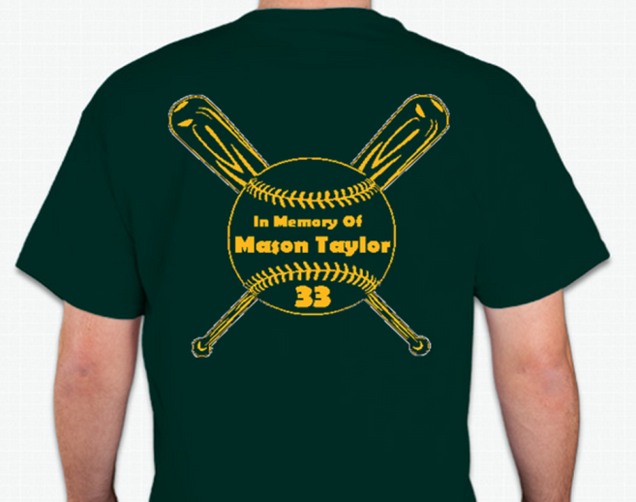
Bracelets $2.00 Each
Please Indicate Quantity and Size
Toddler (6 inch) ______ Adult (8 inch) ______
Youth (7 inch) ______ Total Price:

